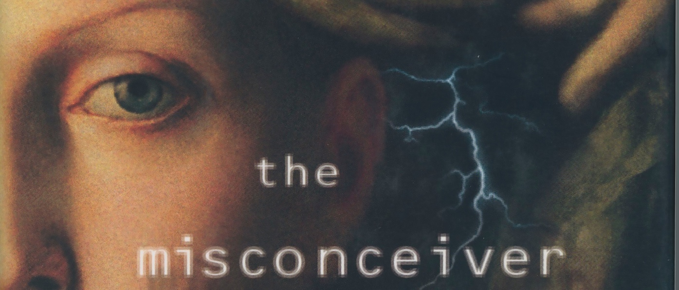

Book Club Guide
I’m delighted that you’ve chosen to read my novel The Misconceiver. Here’s an introduction, links, and discussion questions to help broaden your conversation.

An epochal novel, brought back to life

I first wrote and published this book in 1997, after the Supreme Court’s affirmation of reproductive rights in Planned Parenthood v. Casey, when I was receiving postcards warning that the anti-choice movement would put its full force behind overturning Roe v. Wade. What did that mean for women’s future? What would it be like to come of age in a country where women’s rights were being curtailed rather than strengthened? What other rights were o the line for people of color, for gay people? I did some research into legal scholars’ predictions of what would befall us, and into the history of abortion pre-Roe. Then my imagination met Phoebe Masters, and I wrote this book. Little did I know how close many of its predictions would come. But with the June 2022 Supreme Court decision in Doe, the process that lies in the imagined past of The Misconceiver has become our present, and a challenge to our future. The chorus to republish the novel rang loud and clear.
While most of my predictions about technology in this new world fell wide of the mark, the drumbeat against women’s progress that we are hearing in the 2020s rings uncomfortably true. I am fortunate that Wandering Aengus Press was willing to take a chance on helping The Misconceiver rise from the ashes. Reading it today, knowing when it was written, we may be able to look ahead with clearer vision, and change our future before we are robbed of it.

All author proceeds from sales of The Misconceiver go toward supporting a woman’s right to choose.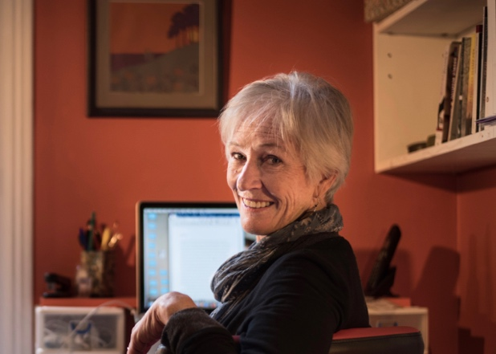
Lucy Ferriss

Characters

Phoebe Masters. Born at the millennium, 5 when her mom dies, 7 when Roe v. Wade is overturned, 11 when Congress passes the Human Life Amendment. Ambivalently she follows in the steps of her beloved sister, Marie, who was arrested for performing illegal “misconceptions” and died of E. coli poisoning in prison. More than anything, Phoebe wants to prove herself worthy of her mother and sister—and is on a journey to claim her own place in the world she’s inherited.
Lloyd, Phoebe’s lawyer cousin, a broker for misconceptions. A no-nonsense guy who trusts family above all else.
Lydia, Phoebe’s supervisor at Viratect. She appeared at Marie’s funeral and offered Phoebe the job out of what she explained was a long friendship with Marie.
Jonathan, Phoebe’s coworker at Viratect; in a clandestine relationship with Gerald, an older colleague.
Tim, a self-avowed Pentecostalist, also on the Viratect team.
Christel, Phoebe’s niece, a Christian who’s taken a Purity Pledge. Her father, Frank, Phoebe’s brother, died of TB-2 several years ago.
Roxanne, Phoebe’s sister-in-law, Christel’s mother, living in California and hoping for a new husband.
Arthur Levinsky, an orthopedist, whom Roxanne is dating at the start of the story.
Sheri, a fellow inmate in Softjail, a lesbian who has refused to disclose the location of her son or who has custody of him.
Heather, also in Softjail, a former associate of Marie’s in the underground misconceiver network.
Discussion questions

• Do the characters and events in The Misconceiver seem realistic when you think about the near future, or do they seem like dystopic fantasies?
• Phoebe asks each of her patients, “Do you want me to kill your baby?” Why this question? Does it make you like or dislike Phoebe? Does it make The Misconceiver a pro- or anti-choice book?
• How do you feel about Marie, Phoebe’s late sister? Do your feelings toward her change in the course of the novel?
• Even though the book was written before same-sex marriage was legal, the laws and social mores of its imagined world are as anti-gay as they are anti-choice. Does the parallel between reproductive rights and LGBTQ rights feel realistic or imaginary?
• The character who changes most in the book is Christel. What causes her change, and what—if any—political conclusions do you draw from it?
• Behind much of the fear stoking the plot of The Misconceiver is not the government so much as the Coalition. What do you make of the Coalition? Do you find any echoes of it in our world?
• If this novel were being written today—that is, with a story taking place in 2042, 20 years after the overturn of roe v. Wade—in what ways would it differ from The Misconceiver? In what ways would it be the same?
• Phoebe falls in love with a doctor, an unlikely partner. What draws her to him? Have you experienced anything similar?
• What do you make of Phoebe’s choice at the end of the book? Do you consider it a happy or a sad ending?
For more discussion prompts, see the Q&A with Lucy on her website.

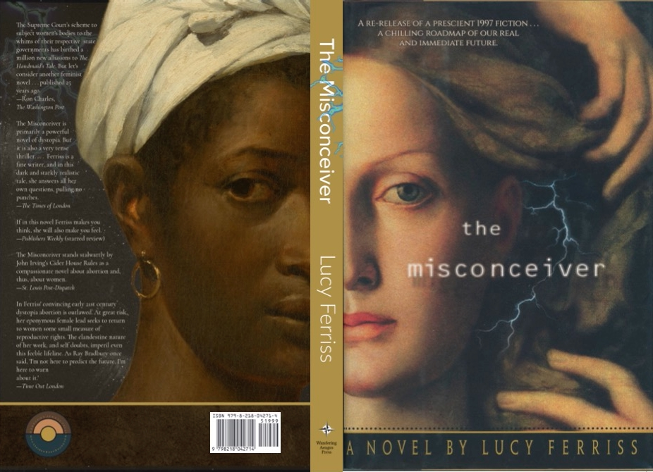
Some links and suggested reading

• To keep up with what’s happening with The Misconceiver, other books, and life in general on this changing and threatened planet, consider subscribing to my newsletter. I send it out about once every two months, and love hearing back from readers.
• For other novels about abortion and women’s reproductive choices, check these out:
Kate Manning, My Notorious Life. Inspired by a real midwife who became one of the most controversial figures in Victorian New York.
Leni Zumas, Red Clocks. Also a dystopic novel in which abortion in banned throughout the U.S., but told from a variety of women’s perspectives and desires.
Naomi Alderman, The Power. Winner of the Baileys Prize for Women’s Fiction, this satire features teenaged girls who suddenly discover they can produce a deadly electrical charge.
Hillary Jordan, When She Woke. An updating of The Scarlet Letter for the post-abortion age.
And of course Margaret Atwood, The Handmaid’s Tale, which inspired us all.
• To contribute to the ongoing work of protecting a woman’s right to choose and other human rights, please consider donating to these organizations:

Planned Parenthood
National Abortion Rights Action League
National Organization for Women
Black Women’s Reproductive Agenda
Center for Reproductive Rights
National Abortion Federation

